Matchmaking & Lobby System v. 0.3

Overview
Every game on this platform currently assumes the player opens it and starts playing. That stops being true the moment a second, multiplayer robot game ships alongside the first, because at that point the platform has to answer a question none of the existing games ask: what kind of session does the player want, and how do they get into one with the people they want to play with.
This document proposes the answer as a single shared system rather than a per-game one. First, the mode-select decision belongs above any individual game, not inside it. A player choosing between singleplayer and multiplayer robot games is choosing a session type, not a level, and asking that question once at the platform level means every future game plugs into the same front door instead of each one reinventing a main menu.
Second, “multiplayer” is not one path, and it is not two either. A player who wants to play with a specific friend, a player who wants to play with whoever is available, and a group of friends who want strangers to fill the empty seats are all solving different problems. Collapsing them into one “Play Online” button serves none of them well. This document keeps them as distinct paths inside the same lobby screen: Private Room (code only, no strangers), Public Room (code and matchmaking fill), and Quick Match (matchmaking only).
The middle option is the one that lets two friends play together against other people online. It works by inverting the order of the usual party system: rather than forming a group and then queueing, the room is created for a chosen game first and matchmaking fills the remaining seats around it. That inversion is what avoids the coordination problem a pre-matchmaking party system would create on a shared platform, where a party of six formed before game select breaks the moment they pick a four-player game. A room’s capacity comes from the game it was created for, so it can never hold more players than that game supports.
Third, the choice of Photon Fusion as the networking layer is already made, which fixes the shape of both paths. A room code in this system is a Photon Fusion session name; matchmaking is Photon Fusion’s own session-fill logic reading session properties this document defines. Nothing here proposes a custom matchmaking server or a queueing backend — the goal is to get the most out of what Fusion already does, not to build around it.
This version of the document carries every open networking decision for the whole platform. The driving foundation document set — eight documents covering the shared driving layer that future robot mini-games are built on — deliberately makes no networking decisions. Instead, its Vehicle Network Sync document states what the driving simulation requires, and every choice about how to satisfy those requirements is presented here, in the Technical Networking Decisions section, as an option set with consequences. The intent is that the development team rules on these during implementation, with the trade-offs written down rather than rediscovered.
Every numeric value in this document is provisional. The structural decisions — the four-screen flow, the two join paths, session-properties-based matchmaking — are the load-bearing part.

Platform Context
Constraints set outside this document, recorded because the design depends on them.
PC only. Keyboard and gamepad on desktop. Nothing in this document assumes a mobile client.
Robots are chosen and customised before a mini-game launches, using a roster and customisation system that already exists on the platform. This is relevant here because it implies some form of persistent player identity already exists, which bears directly on Open Design Decision 4 below.
No local multiplayer. One player per client. Two players sharing a machine is not supported.
No late join and no rejoin. Everyone who is in the lobby when the host starts begins the match together. A player who leaves or disconnects is gone for that round, and cannot rejoin it. This is a deliberate simplification, not an oversight.

Design Goals
These are the standards this system is checked against. A screen or flow that fails one of them does not ship.
- The path to a match is never more than three steps from the main menu. Main Menu to Mode Select to Multiplayer Lobby to Quick Match is three steps; anything that adds a fourth mandatory screen before a player can start searching needs a specific justification.
- A player who wants to play only with friends never has to touch matchmaking. A Private Room must work with zero strangers involved at any point, including in the underlying Photon session — a private room is never visible to the matchmaking pool. Exposure to strangers is always an explicit, opt-in choice made by the host, never a default and never a side effect. 2b. A group of friends can play together against strangers without a party system. The room is created for a chosen game, friends join by code, and matchmaking fills the rest. No pre-matchmaking party, and therefore no party-size mismatch across games.
- A player who wants to play now never has to wait on another player’s action. Quick Match must be a solo action from click to match found.
- Every screen has a defined state for every outcome, including failure. Wrong code, full room, closed room, matchmaking timeout and connection loss each render a specific message, not a generic error.
- The system is shared, not per-game. A game team drops in a scene reference and a max party size; they do not reimplement the lobby.
- Singleplayer is a first-class sibling of multiplayer, not an afterthought bolted beside it. The mode-select screen is built as a real fork now, even though only one side has content today, so no future game has to retrofit the choice.
- The document set makes no networking decisions except here. Every technical networking choice is presented in one place, with its consequences, for the development team.

Core Mechanics

The Flow Model
Player intent resolves through four layers. Only the last one touches the network.
Layer | What it is | Where it lives | Where it is documented
Layer 0 - Mode Select | Singleplayer or Multiplayer, chosen once per session launch | Platform shell, above any individual game | This document
Layer 1 - Game Select | Which singleplayer or multiplayer game to launch | Per-game catalogue screen | Game Catalogue spec (not yet written)
Layer 2 - Multiplayer Lobby | Create Room (private or public) or Quick Match, plus the waiting room | Platform shell, shared across all multiplayer games | This document
Layer 3 - Photon Fusion Session | The actual NetworkRunner session: authority model, session properties, player list | Networking layer | This document, plus the driving foundation’s Vehicle Network Sync for its requirements
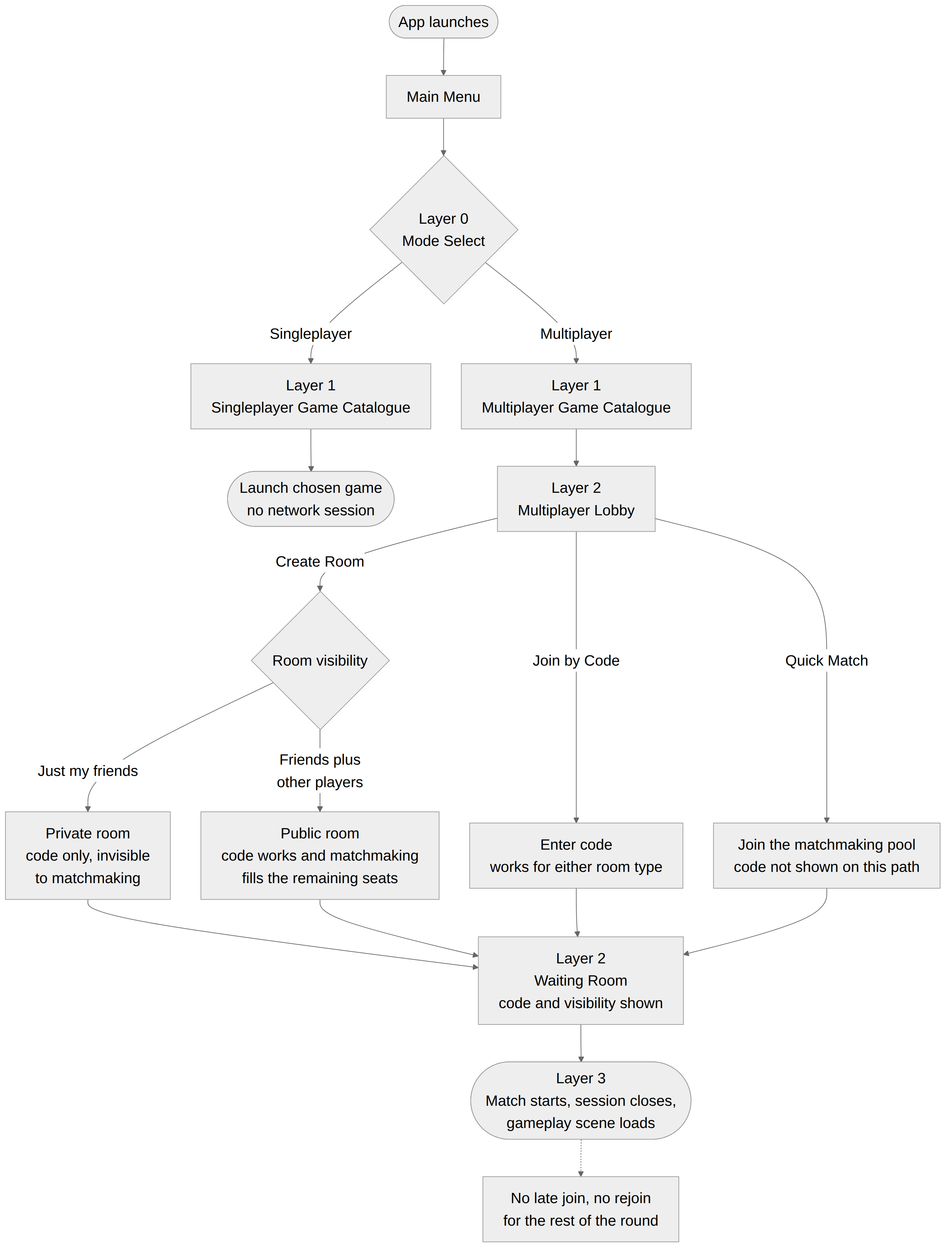
Note on Layer 1. Singleplayer’s catalogue has no entries at the time of writing. It is included in the flow model regardless, per Design Goal 6, so the fork exists structurally before it needs content.

Why the fork sits above the game, not inside it
The alternative is each game owning its own main menu with its own Singleplayer/Multiplayer choice baked in. That works until a player owns two multiplayer games, at which point they are learning a second mode-select screen that looks almost like the first one and behaves slightly differently. Putting Mode Select and the Multiplayer Lobby in the platform shell means every game after the first inherits a working lobby for free.

UI Flow

Screen 1: Mode Select
The first screen after the main menu. Two large options, Singleplayer and Multiplayer, nothing else. No account gate, no network call, sits entirely on-device.
Element | Behaviour
Singleplayer option | Routes to the Singleplayer catalogue. No Photon Fusion involvement at any point in this path
Multiplayer option | Routes to the Multiplayer Lobby

Screen 2: Multiplayer Lobby
The fork inside multiplayer. Three actions, presented as equal peers rather than a primary and two alternates.
Element | Behaviour
Create Room | Prompts for room visibility — Private or Public — then generates a room code, opens a Fusion session and takes the player straight to the Waiting Room as the sole occupant and host
Join by Code | Opens a code entry field. On a valid code, joins the matching session and proceeds to the Waiting Room. Works identically for private and public rooms
Quick Match | Opens the matchmaking pool immediately, no further input required. Proceeds to the Searching state
The visibility prompt. Two options, worded around intent rather than around the underlying mechanism:
Option | Wording | Behaviour
Private Room | “Just my friends” | Code only. Invisible to matchmaking. Nobody joins who was not sent the code
Public Room | “My friends, plus other players” | Code works as normal, and matchmaking fills the remaining seats
This is one extra step on the Create Room path only. Quick Match, which is the path with the strictest step budget under Design Goal 1, is untouched.

Screen 3a: Waiting Room (Create Room / Join by Code path)
Element | Behaviour
Room code | Displayed large, with a one-click copy action. Visible for the lifetime of the room, in both private and public rooms
Visibility state | Clearly indicated — “Private” or “Open to other players” — so nobody is surprised by a stranger arriving. Whether the host can change it after creation is Technical Decision N10
Player list | Live list of joined players by persistent account name, supplied by the launcher, with the host marked distinctly. Updates as players join or leave. A player who arrived by matchmaking rather than by code is not distinguished — once in the room, everyone is a player
Ready state | Non-host players toggle Ready. Host sees a per-player ready indicator
Start button | Host-only. Disabled until the minimum player count for the selected game is met. Non-hosts see “Waiting for host to start” in its place
Leave | Returns to the Multiplayer Lobby

Screen 3b: Searching (Quick Match path)
Element | Behaviour
Searching indicator | Animated state, plus elapsed search time
Cancel | Returns to the Multiplayer Lobby and leaves the matchmaking pool cleanly
Match found | Transitions automatically to the Waiting Room once Fusion places the player into a session
Timeout | See Balance Considerations for the provisional timeout value and its fallback behaviour

Screen states, both waiting paths
State | Visual treatment | Cause
Idle | Default state, action buttons enabled | Fresh entry to the Lobby screen
Searching | Spinner, elapsed time counter, Cancel enabled | Quick Match in progress
Code invalid | Field outlined red, inline message | Code does not match any open session
Room full | Blocking message, returns to Lobby | Join attempted on a session already at capacity
Room closed | Blocking message, returns to Lobby | Join attempted on a session the host has already started or left
Connecting | Spinner, no cancel | Between a valid join attempt and Fusion confirming the connection
Connection lost | Blocking message, returns to Lobby, not Main Menu | Network drop at any point after Connecting

UI Flow diagram
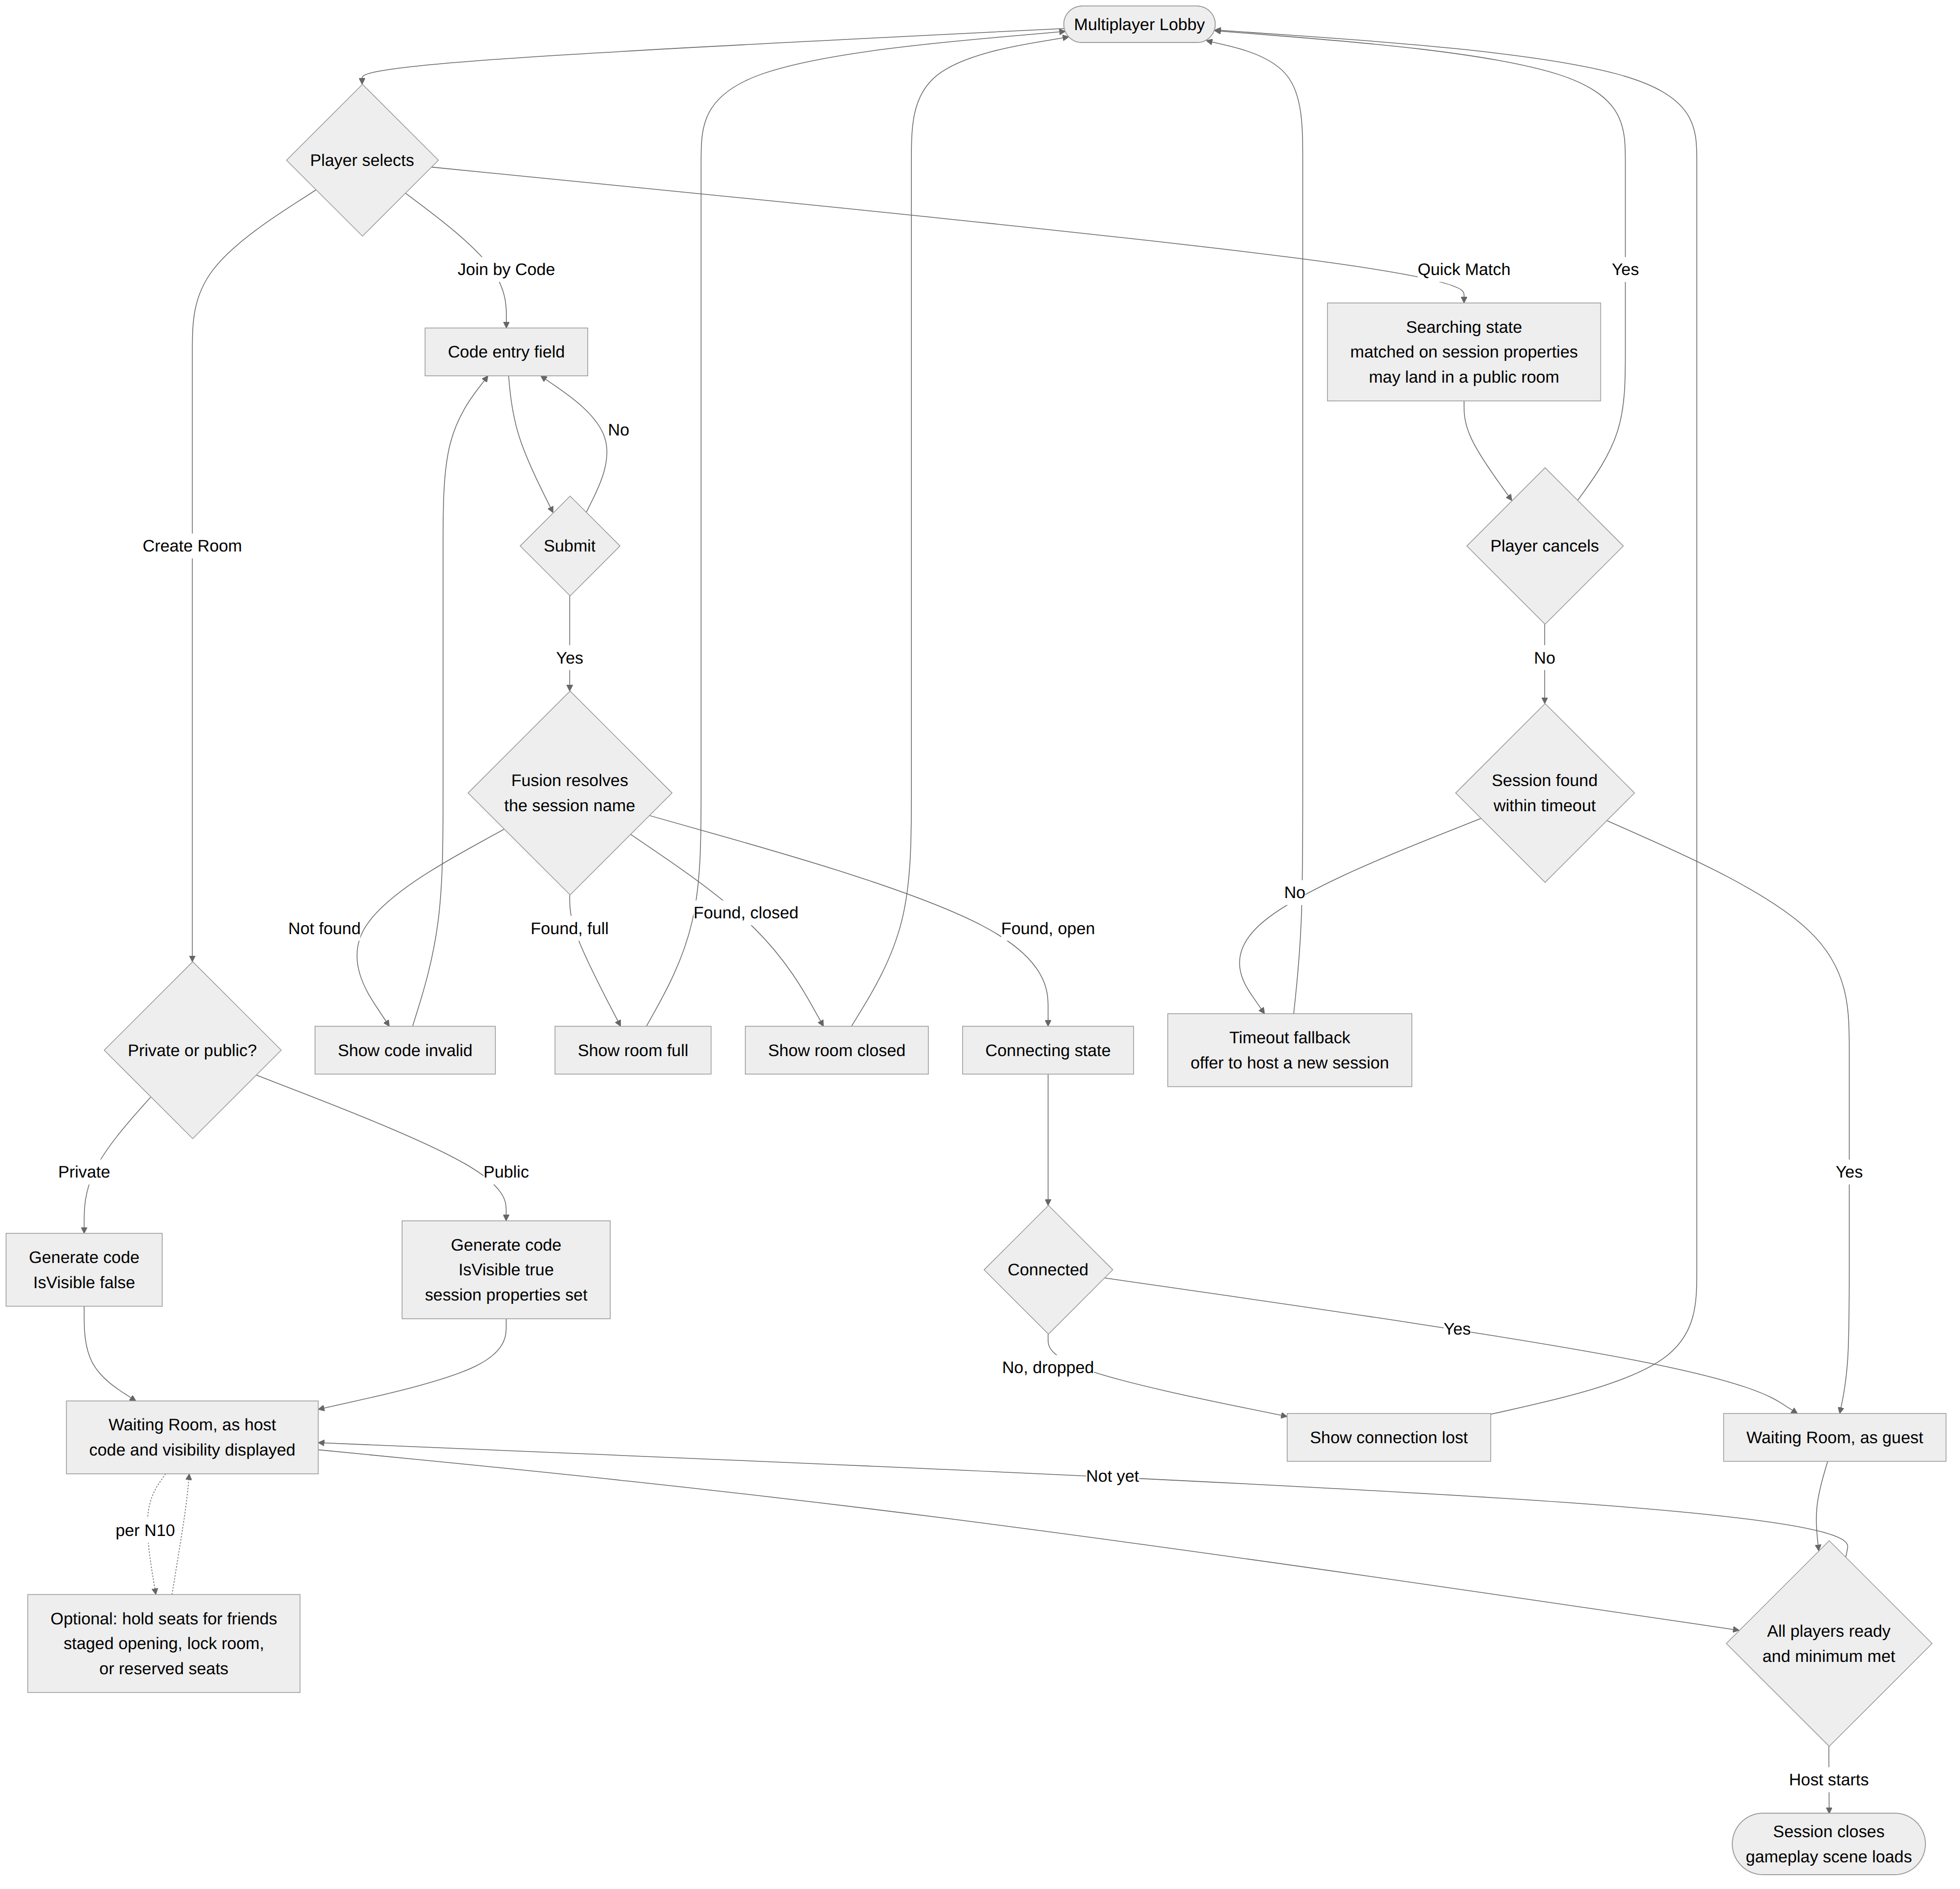

Matchmaking System

Create Room (private or public)
The host calls StartGame with a freshly generated SessionName, with IsVisible set from the visibility choice, and with SessionProperties populated in both cases.
Visibility and the code are independent properties, and always have been. A Fusion session can be named and visible; the two are separate flags. The original draft of this document happened to pair them — Create Room took a code and was invisible, Quick Match was visible with an auto-generated name nobody could type — but nothing required that pairing. Decoupling them is what makes a public room possible, and it is a parameter change rather than a new system.
 | Private Room | Public Room | Quick Match
SessionName | Generated code | Generated code | Generated code, not shown to the player
IsVisible | false | true | true
SessionProperties | Set, unused | Set, read by matchmaking fill | Set, used to search
Who can join | Code holders only | Code holders and matchmaking | Matchmaking only
Every session is now created with a real 5-character name, including Quick Match sessions, so that the naming scheme is uniform and a session’s code is always meaningful even where it is not surfaced. The code is deliberately not displayed in the Quick Match waiting room. A player placed into a stranger’s partly-full room has no control over how quickly it fills, so an invite sent from that screen would fail with “Room Full” often — and most often precisely when matchmaking is working well. An invite that fails half the time is worse than no invite, because players stop trusting it. A group who want to play together against strangers should create a Public Room, which is the path built for that.
Code generation. A 5-character alphanumeric code, excluding visually ambiguous characters (0/O, 1/I/l), giving roughly 32 million combinations. Generated client-side, passed as the Fusion SessionName. On the rare case Fusion reports the name already taken, the client rerolls and retries once before surfacing an error.
Code lifetime. The code is valid for the lifetime of the session. It is not a separate object with its own expiry — there is no code database, no server component, and nothing to garbage-collect. The session is the code.

Join by Code
The joining client calls StartGame with SessionName set to the entered code, uppercased and trimmed before submission. Fusion attempts to resolve that session name directly against the region’s active sessions; it does not need a lobby join or a session list.
Identical for private and public rooms. The joining client does not need to know which it is joining, and the code entry screen does not ask. A code either resolves to an open session with a free seat or it does not, and the four failure states — invalid, full, closed, connection lost — are the same in both cases.

Quick Match
The searching client calls JoinSessionLobby to enter Fusion’s default lobby, then calls StartGame with no SessionName set and SessionProperties describing what it’s looking for — at minimum, which game it’s trying to join, since the shared lobby system will have several multiplayer robot games generating sessions concurrently. Fusion’s matchmaking then either places the client into an existing open, visible session whose properties match, or the client itself opens a new visible session if none is found, so the very first player searching for a given game becomes the host of the session the next player finds.
Session properties carried at minimum:
Property | Purpose
GameID | Which multiplayer robot game this session is for. Prevents cross-game matching
PartySize | Current occupied slots, read by Fusion’s fill logic
MaxPartySize | Provisional per-game value, see Balance Considerations
Region | Set implicitly by Photon’s regional routing, not authored per-session
Public rooms improve Quick Match as a side effect. Today the first player searching for a given game becomes the host of an empty session and waits for someone to find it. Once public rooms exist, the matchmaking pool contains partly-full sessions with two or three friends already in them — and a partly-full session is exactly what Fusion’s fill logic prefers over an empty one. A solo player searching lands in a room that is already half-populated, which shortens their wait. The two features feed each other rather than competing.

Technical Networking Decisions
This section is for the development team. Every networking decision on the platform is collected here, presented as options with their consequences. None of them are made by the design documents. The driving foundation’s Vehicle Network Sync document states the requirements these rulings have to satisfy; it is referenced below as “the requirements document”.
The requirements that constrain most of these decisions, in short:
- The local player’s own robot must respond to input on the tick the input was given
- Two robots in contact at speed must produce the same outcome on both screens
- Corrections must be absorbed visually, never snapped
- Every simulation-relevant value must be replicated and must survive a rewind
Two robots contesting a bump is the hardest thing this platform asks of its network layer, and it is a much less forgiving case than anything in the lobby itself.

N1 — Authority model: Host mode versus Shared mode
The largest decision, and the one that most affects how the driving foundation behaves.
Option | What it means | Affects
GameMode.Host | One peer holds authority over the whole simulation. Clients predict locally from their own input and reconcile against the host’s result | Contested contact resolves cleanly, on one authority, which is what the driving foundation’s contact requirements assume. Standard prediction and reconciliation. Cost: a host disconnect ends the match for everyone, since there is no automatic migration. Also gives the host a small latency advantage unless N4 removes it
GameMode.Shared | Authority over each robot sits with its owner and is relayed through Photon Cloud | Removes the host-disconnect problem entirely, and simplifies the lobby’s host-leaves case. Cost: a contested bump is resolved by two different authorities with two different views of when it happened, which is the exact case the driving foundation is least able to absorb. Adds relay latency on every state update
Design’s view, for information: Host mode is what the driving foundation was written against, and the contact requirements are considerably easier to satisfy under it. The residual risk — a host disconnect ending a match in progress — is real and should be accepted knowingly rather than discovered. Short rounds reduce the exposure window, and host selection preferring the best-connected peer reduces the frequency. Host migration mid-match is a substantial project and is not proposed.
Interacts with: N4 (hosting architecture), and the lobby’s host-leaves edge cases below.

N2 — Tick rate
Option | Affects
60 Hz | Best feel and the tightest contact resolution. Roughly double the bandwidth and CPU of 30 Hz
30 Hz | Halves bandwidth and CPU. Interpolation covers most of the visual difference. Doubles the wall-clock duration of every tick-denominated value in the driving foundation
Timing matters on this one. The driving foundation’s drift release window is specified as 24 ticks — roughly 0.4 seconds at 60 Hz, 0.8 seconds at 30 Hz. Every other tick-denominated value in the set behaves the same way. Profile values are authored in per-second terms and converted at load precisely so that a tick rate change does not silently retune every robot, but the release window is an input-timing value and its wall-clock duration genuinely changes how the game feels.
This ruling should therefore be made before the drift tuning pass begins, or that pass will need repeating.
Interacts with: N3 (interest management) and N6 (bandwidth), since tick rate is the largest single lever on bandwidth.

N3 — Interest management
Photon Fusion can reduce the update rate for objects far from a given player, or stop sending them entirely.
Option | Affects
Enabled, generous radius | Meaningful bandwidth saving in a spread-out racing mini-game, where distant robots barely need updating. Saves nothing in a small arena where everyone is always close. Low risk with a generous radius
Disabled | Simplest. Every robot updates at full rate regardless of distance
Design’s view: enable it with a generous radius and treat it as the first lever to reach for if the bandwidth budget in N6 is exceeded. It costs nothing perceptible when the radius is set well.

N4 — Hosting architecture: playing host versus dedicated host
Only relevant if N1 resolves to Host mode.
Option | Affects
Playing host | No infrastructure required. One of the players holds authority and also plays, giving them a small genuine advantage from zero-latency input. A host disconnect ends the match
Dedicated / server-side host | Removes the host’s advantage entirely and removes the host-disconnect problem, since no player holds authority. Cost: requires server infrastructure and its running costs, which do not currently exist
Design’s view: a playing host is acceptable and the advantage is small. Server-side hosting would be preferable if the infrastructure is judged worthwhile, primarily because it also resolves the host-disconnect problem from N1. Worth measuring the size of the host’s advantage on a prototype before deciding it matters.

N5 — Rollback depth and correction thresholds
Parameter | Provisional | Affects
Maximum rollback depth | ~20 ticks (330 ms at 60 Hz) | How much latency can be reconciled by re-simulation. Beyond it, a client is hard-corrected with a blend — visible but rare
Interpolation delay for remote robots | ~6 ticks (100 ms) | Trades smoothness against how stale other players’ robots look. Too short causes stutter; too long makes contact prediction worse
Correction blend window | ~10 ticks (165 ms) | How long a correction takes to absorb. Must never be zero — a snapping robot reads as a broken game
Position correction threshold | ~0.05 m | Divergence below this is ignored rather than corrected, avoiding constant micro-corrections
Rotation correction threshold | ~2 deg | Same, for yaw
These are engineering values with feel consequences. The only hard requirement from the driving foundation is that the correction blend window is never zero.

N6 — Bandwidth budget
Stated as a target the other decisions must fit within.
Case | Target
Input, per client per tick | ~2 bytes plus Fusion overhead and redundancy
Networked robot state, per robot per tick | Under 40 bytes compressed
4 players at 60 Hz | Under 12 KB/s down per client before Fusion overhead
8 players at 60 Hz | Under 24 KB/s down per client
The eight-player case at 60 Hz is the one to measure on a prototype before N2 is committed. If it does not fit, the levers in preference order are: enable interest management (N3), increase compression on position and velocity, drop to 30 Hz (N2), and only then reduce what is replicated. Reducing replicated state is last because every item on the requirements document’s list is load-bearing for a mechanic.

N7 — Contact authority split
Contact type | Requirement | Why it is worth noting
Robot-to-robot | Must resolve on one authority | Two robots, two owners, one truth
Robot-to-world | May resolve locally on every peer | Walls do not move and every peer has identical geometry, so wall contact is deterministic from replicated state alone. Wall contact is far more frequent than robot contact, so this is a meaningful saving available under either authority model
Robot-to-prop | Local, non-authoritative | Props are cosmetic and divergence has no consequence
Out of bounds and stuck respawn | Authoritative | Triggers a respawn other players see
This is a requirement rather than a decision, but it is recorded here because the saving on wall contact is easy to miss and is worth taking.

N8 — Determinism enforcement
Not a decision so much as a strong recommendation, recorded here because it is an engineering investment that needs scheduling.
A determinism violation in the driving simulation does not produce a bug that looks like a networking bug. It produces intermittent desync that gets misdiagnosed as a physics problem for weeks. Two measures make that class of bug cheap:
- State hashing in development builds. Hash each robot’s networked state per tick on every peer, log mismatches with the field, tick and magnitude. A violation then surfaces as a named field on a named tick.
- A soak test in continuous integration. Two headless clients, a fixed input script, a fixed tick count, hashes compared at the end; divergence fails the build.
This is the single highest-value engineering investment across the whole platform, because it converts the most expensive class of bug into a build failure.

N9 — Fusion API confirmation
The API surface referenced across this document and the driving foundation set reflects Fusion 2’s documented behaviour. Exact signatures and semantics should be confirmed against the SDK version pinned in the project before implementation, the same way any other third-party integration would be.

N10 — Holding seats for friends in a Public Room
This is an open technical decision, and design has no strong preference between the options below. It is the one part of the Public Room feature that is not simply a parameter change, and it should be settled by whoever can answer the Fusion question underneath it.
The problem it solves. A Public Room is created, matchmaking begins filling it, and a friend the host invited by code arrives thirty seconds later to find the room full. The room did exactly what it was asked to do; the friend still got shut out. How likely this is depends on how quickly the pool fills a room, which nobody can know until there is live traffic — it may be a rare annoyance or the normal case.
The Fusion question underneath all of it. Every option below depends on whether a live session’s IsVisible flag and SessionProperties can be changed after StartGame, and how promptly the matchmaking pool reflects that change. If they can be changed cleanly, all four options are open. If they cannot, only Option A works, since it makes the decision before the session becomes visible at all. This should be confirmed against the pinned SDK version before choosing.

Option A — Staged opening
The room is created private. The host shares the code, waits for friends, then presses “Find more players”, at which point the session becomes visible and matchmaking begins filling the remaining seats.
Removes the race | Completely. Friends are already in the room before any stranger can be matched into it
Fusion requirement | One visibility change, at a moment of the host’s choosing, with no contention
Cost | One extra host action, and a host who forgets to press it sits in a private room wondering why nobody is arriving
Note | The visibility prompt at creation could be dropped entirely under this model, with every room starting private and “Find more players” being the only way to open one. That is arguably simpler, at the cost of making the common solo-host case slower

Option B — Lock Room
The room is created public and fills immediately. A “Lock Room” toggle in the Waiting Room sets the session invisible, stopping the fill and holding the remaining seats.
Removes the race | Partially. The host has to lock before the room fills, which is a reaction rather than a guarantee
Fusion requirement | Visibility change on a live, actively-filling session
Cost | Cheapest of the four. Useful regardless of what else is chosen, since a host may want to stop a fill for other reasons

Option C — Reserved seats
At creation the host declares how many seats to hold back. The session advertises a reduced MaxPartySize to matchmaking while its true MaxPlayers stays at the game’s value, so code-joiners can take the held seats but matchmaking cannot. The host releases them manually, or they release on a timer.
Removes the race | Completely, for as many friends as were declared
Fusion requirement | The most demanding. Depends on the fill logic respecting an advertised property rather than actual occupancy, and on that property being updatable
Cost | Most flexible and most complex. Adds a number for the host to choose at creation, which is one more decision on a screen that currently has one

Option D — Accept it
Ship Public Rooms as specified, measure how often a code-join hits a full public room once there is real traffic, and add one of the above only if the number justifies it.
Removes the race | No
Fusion requirement | None
Cost | Nothing now. The risk is shipping a feature whose main use case fails often enough to sour players on it

If a decision is wanted before the Fusion question is answered
Option A plus Option B is the combination that needs the least from the SDK while covering the most cases: rooms start private, the host opens them deliberately, and the lock toggle exists for the host who opens one and then changes their mind. Option C can be added later without disturbing either. Whichever is chosen, the requirement from design is only that a host who wants to hold seats for a friend has some way to do it — the mechanism is genuinely open.

Summary of what each decision touches
Decision | Touches
N1 Authority model | Contact resolution, host-leaves behaviour, latency profile, every driving module
N2 Tick rate | Bandwidth, CPU, the drift window’s wall-clock feel — decide before drift tuning
N3 Interest management | Bandwidth in spread-out games only
N4 Hosting architecture | Fairness, infrastructure cost, host-disconnect exposure
N5 Rollback and thresholds | How corrections look and feel
N6 Bandwidth budget | Constrains N2 and N3
N7 Contact authority split | Efficiency; the wall-contact saving is free under any model
N8 Determinism enforcement | Engineering schedule, debugging cost across the whole project
N9 API confirmation | Implementation accuracy
N10 Holding seats for friends | Whether the Public Room’s main use case works reliably. Depends on a Fusion capability question

Networking & Photon Fusion Implementation

Data structures
RoomConfig {
SessionName // a real 5-character code on every path
GameMode // per N1
Visibility // Private or Public. Set by the host on Create Room
IsVisible // derived from Visibility. True for Public and Quick Match
MaxPlayers // from the selected game. Never exceeded by any join path
ReservedSeats // per N10 Option C, if adopted. 0 otherwise
SessionProperties {
GameID
PartySize
MaxPartySize // may advertise below MaxPlayers, per N10 Option C
}
}
LobbyUIState {
Screen // ModeSelect, VisibilityPrompt, MultiplayerLobby,
// WaitingRoom, Searching
ConnectionStatus // Idle, Connecting, Connected, Failed
PlayerList[] // populated once connected
IsHost
RoomCode // display value. Shown on Create/Join paths only,
// deliberately withheld on the Quick Match path
RoomVisibility // displayed in the Waiting Room so nobody is surprised
}

Key methods
// Mode Select and routing
SelectMode(mode) // Singleplayer or Multiplayer, local only
OpenMultiplayerLobby()
// Create / Join
CreateRoom(gameID, visibility) returns RoomConfig // code plus IsVisible from choice
JoinRoomByCode(code, gameID) returns bool // resolves SessionName directly
SetRoomVisibility(visibility) // host-only, per N10. May not be
// supported on a live session
// Quick Match
StartQuickMatch(gameID) // JoinSessionLobby, then StartGame with properties
CancelQuickMatch() // shut down the runner cleanly, return to Lobby
// Waiting Room
SetReady(playerRef, isReady)
CanStart() returns bool // host-only check, all ready and min met
StartMatch() // host-only, closes the session, loads the gameplay scene
// Callbacks (INetworkRunnerCallbacks)
OnPlayerJoined(runner, player)
OnPlayerLeft(runner, player)
OnSessionListUpdated(sessionList) // Quick Match path only
OnConnectFailed(runner, reason)
OnShutdown(runner, reason)

Connection sequence
All three paths follow the same shape once a target session is identified: the client calls StartGame, Fusion resolves the connection, and OnPlayerJoined fires on every existing client in the session including the new arrival. The Waiting Room’s player list is built entirely from that callback rather than from a separate roster call, so there is exactly one source of truth for who is in the room.
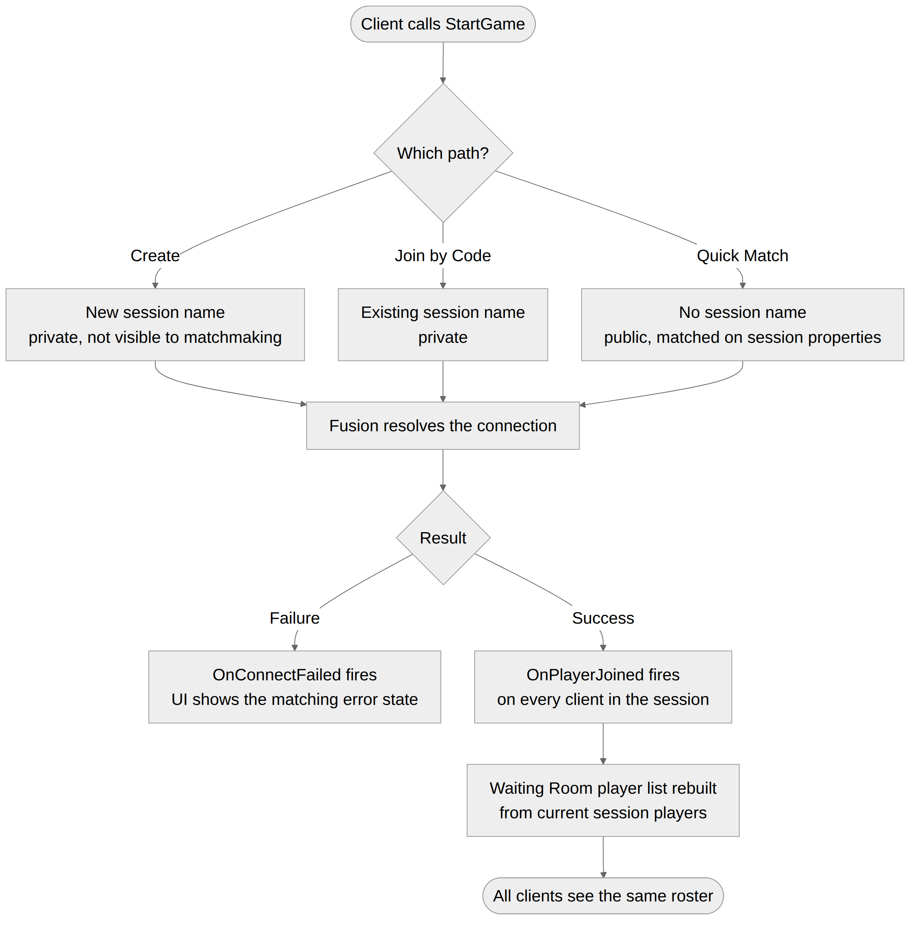

Multiplayer Behaviour
Element | Model | Reason
Room code | Equals the Fusion SessionName, generated client-side, on every path | No server component needed to mint or validate codes
Session visibility | Chosen by the host on Create Room. Always true for Quick Match | Visibility and the code are independent flags. Pairing them was a convention, not a constraint
Private room exposure | Never visible to matchmaking, under any circumstance | Keeps Design Goal 2 true structurally, not by convention
Public room capacity | MaxPlayers comes from the selected game and is never exceeded by either join path | The reason a public room cannot suffer the party-size mismatch a pre-matchmaking party system would
Holding seats for friends | Per N10 | Open technical decision
Authority model | Per N1 | Open technical decision
Session properties | Set once at StartGame, read by Fusion’s matchmaking fill logic | Matches Fusion’s own filtering mechanism rather than layering a custom one on top
Join during Waiting Room | New player triggers OnPlayerJoined on all existing clients, UI rebuilds the roster | Single source of truth, no separate roster sync needed
Join after match start | Not possible. The session closes on StartMatch | Late join is not supported
Rejoin after disconnect | Not possible for the current round | Rejoin is not supported
Host leaves during Waiting Room | Depends on N1. Under Host mode this ends the session for everyone remaining | Recorded as a consequence of N1 rather than a separate decision
Player disconnects during Quick Match search | Client shuts down its runner, no session was ever joined | Nothing to clean up server-side

Balance Considerations

Tuning parameters
Parameter | Provisional value | Range | Purpose
room_code_length | 5 characters | 4 to 6 | Balance of typing friction against collision odds
quickmatch_timeout | 30 seconds | 15 to 60 | How long a player searches before the fallback triggers
quickmatch_timeout_fallback | Offer to host a new open session | Fallback, or extend search | What happens when nobody is found in time
max_party_size | 4 (provisional, per-game override expected) | 2 to 8 | Set per multiplayer robot game, not platform-wide
min_party_size_to_start | 2 | 1 to max | Whether a host can start solo or must wait for a second player

Why these are unset rather than guessed precisely
Every value above depends on a variable this document cannot see: how many multiplayer robot games exist, how many players are online at once, and what a single match actually asks of a party. A four-player default is reasonable, but the number belongs to each game’s own design, which is why max_party_size is written as a per-game override rather than a platform constant.
max_party_size also feeds directly into the driving foundation: Track Data requires one start anchor per party slot, and the bandwidth case in N6 scales with it.

Edge Cases
- Two players submit the same room code simultaneously. Both resolve independently against the same open session; the second to complete the handshake becomes the next player in the roster. No special handling needed.
- A player enters a code for a room that has already started. The session reports closed once the host starts the match. The client sees Room Closed and returns to the Lobby rather than joining mid-match.
- A player enters a code for a room that never existed. Fusion cannot resolve the session name. Client sees Code Invalid after a defined connection-attempt timeout, not instantly, since a slow network and a wrong code look identical for the first moment.
- The host leaves the Waiting Room before starting. Behaviour depends on N1. Under Host mode this ends the session for everyone remaining, who see Connection Lost and return to the Lobby.
- A player cancels Quick Match after being placed but before the Waiting Room finishes loading. Treated identically to leaving the Waiting Room normally — the slot frees and OnPlayerLeft fires for the remaining clients.
- Two Quick Match searches for different games collide. Cannot happen by construction: GameID is part of SessionProperties and Fusion’s matchmaking fill only matches sessions whose properties match the searching client’s request.
- Room at capacity when a code-join attempt lands. Client sees Room Full and returns to the Lobby. The room’s MaxPlayers value, not a global constant, governs this.
- A player disconnects mid-match. Their robot is removed after a short grace period. They cannot rejoin. The match continues with the remaining players, and it is each mini-game’s own rule whether a match with too few players remaining should end early.
- A friend’s code-join lands on a Public Room that matchmaking has already filled. The joining client sees Room Full and returns to the Lobby, exactly as it would for any full room. This is the failure case N10 exists to address, and how often it happens cannot be known until there is live traffic.
- A host creates a Public Room and matchmaking fills every seat before the host has shared the code. Legitimate and not an error — the host asked for other players and got them. It is the case that makes N10 Option A (start private, open deliberately) attractive, since under that model it cannot happen.
- A code-join is in flight when the host presses Start. The session closes on StartMatch. A join attempt that completes after that point sees Room Closed, per Edge Case 2. There is no partial state where a player is half-admitted to a starting match.
- A host changes room visibility while a code-join is in flight. Only possible if N10 Options A, B or C are adopted. Making a room private does not eject anyone already in it and does not cancel a join already resolving; it only stops further matchmaking placement. Making a room public mid-session simply opens it to the pool.
- A player joins a Public Room by code and is surprised to find strangers in it. Prevented by the Waiting Room displaying visibility state plainly. A host who wants a strangers-free room chooses Private, and a player who joined by code can see which kind of room they are in.
- Every player except one disconnects mid-match. The remaining player is left alone in a running match. Whether that match should end is a per-game rule, not a lobby concern, but it should be handled explicitly by each mini-game rather than left as an undefined state.

Design Decisions — Resolved
Distinct from the technical networking decisions above, which remain open for the development team. All four design questions previously carried here have been ruled on. They are recorded rather than deleted so the reasoning is available if any is revisited.

1. Skill-based matching — not built
No skill axis, no rating, no bucketing. With one shipped game and no live population, a rating system has nothing to calibrate against, and a placeholder rating costs a data field and UI now for a signal that means nothing until there is enough concurrent traffic to bucket players meaningfully.
Framed as a scheduled revisit rather than a permanent no: worth reconsidering once a game has live matchmaking volume to look at.

2. Friends list and social invite — not built
Sharing a room code through whatever channel the players are already talking on is the whole mechanism. There is no in-app friends list, no social graph and no invite protocol.
Public Rooms are what make this comfortable. The main thing a friends list would have delivered — playing alongside a specific person against other people online — is covered by creating a Public Room and sharing its code. That removes most of the pressure to build a social layer at all.

3. Account and identity — persistent accounts
Players sign in to the platform launcher. The mini-games are a small part of a larger product, and a player is already authenticated before they reach any game. This settles several things at once:
Consequence | Detail
Player list | The Waiting Room shows persistent account names, not session-local nicknames
Player reference | Carries a persistent identity rather than a session-scoped one
Robot customisation | Already keyed to the account, which is why a player’s robot and its customisation follow them across sessions
Rejoin | Becomes technically possible, since a returning player can be recognised. It remains unsupported by decision — see the Platform Context section. The capability existing does not change the ruling
Moderation and reporting | Would have a subject to act on, if ever wanted. Out of scope here
The lobby does not implement authentication. It consumes an already-signed-in identity from the launcher.

4. Party size per game — declared per game
Each mini-game declares its own MaxPlayers at build time. There are no platform-wide party-size tiers, and no shared vocabulary of Duo, Squad and so on.
Consequence | Detail
Track authoring | Track Data requires one start anchor per party slot, so a track is authored against the specific game or games it serves
Bandwidth | The budget in N6 must hold across the full range any game declares, not a small fixed set of cases
Room capacity | A Public Room can never exceed the selected game’s declared number, which is what keeps a friend group from forming larger than the game supports
Team-based games are the known future gap. A mode with two teams needs an even split, a team assignment step and a way to keep a friend group on the same side — none of which this document carries. That is a deliberate omission rather than an oversight, and it should be revisited as a specific piece of work when a team-based mini-game is proposed rather than guessed at now.

Integration Notes
- Requires: Photon Fusion SDK integrated at the project level. A Game Catalogue system for Layer 1, which does not yet exist and is out of scope here. The existing robot roster and customisation system, which is where a player’s chosen robot comes from. The platform launcher’s account system, which supplies the signed-in identity shown in the Waiting Room — this document consumes that identity and does not implement authentication.
- Integrates with: The Driving Foundation document set, which begins where this document’s StartMatch ends. That set makes no networking decisions and depends on the rulings in the Technical Networking Decisions section above.
- Affects: Every future multiplayer robot game’s onboarding flow. The Singleplayer catalogue, structurally. Track authoring, through max_party_size.
- Does not cover: In-match networking once the gameplay scene loads — the driving foundation’s Vehicle Network Sync states the requirements for that. Account and identity. Skill rating. Voice or text chat. Local multiplayer, late join and rejoin, all of which are ruled out.
- Follow up: Re-baseline once the development team rules on N1 through N10. All design decisions in this document are closed. Confirm the Fusion capability underlying N10 — whether a live session’s visibility and properties can be changed after StartGame — before choosing between its options. The tick rate ruling (N2) should come before the driving foundation’s drift tuning pass.

Success Metrics
- A player can go from Main Menu to a full Waiting Room in three steps or fewer for Quick Match, and four for Create Room including the visibility choice
- A Private Room never has a stranger in it, under any circumstance
- Two friends can play together against other players online, with no party system and no account
- A public room never holds more players than its selected game supports
- A player can always tell, from the Waiting Room, whether strangers can join the room they are in
- Every failure state defined in the UI Flow section renders its own message, with no generic error screen left in the build
- A second multiplayer robot game can be wired into the shared lobby by declaring a GameID and MaxPartySize, with no changes to this system’s code
- No player is matched into a session for the wrong game
- No player can join or rejoin a match that has already started
- Every networking decision on the platform is recorded in this document, with its consequences, rather than made implicitly in a design document

Implementation Checklist
A milestone breakdown of everything specified in this document, so that a developer can confirm nothing was missed. Milestones are ordered so that each one is testable before the next begins. An item marked [D] is a decision or confirmation rather than code.

M0 — Decisions and confirmations, before any code
☐ [D] N1 ruled on: Host mode or Shared mode
☐ [D] N2 ruled on: tick rate. Must be settled before the Drift & Boost tuning pass begins
☐ [D] N3 ruled on: interest management enabled or disabled
☐ [D] N4 ruled on: playing host or dedicated/server-side host
☐ [D] N5 ruled on: rollback depth, interpolation delay, correction blend window and thresholds
☐ [D] N6 bandwidth budget accepted, with the eight-player case identified as the one to measure
☐ [D] N7 contact authority split confirmed, including resolving wall contact locally
☐ [D] N8 scheduled: state hashing in development builds, soak test in continuous integration
☐ [D] N9 done: Fusion 2 API surface confirmed against the pinned SDK version
☐ [D] N10 ruled on: whether and how a host can hold seats for friends in a Public Room
☐ [D] The Fusion capability underlying N10 confirmed — can a live session’s IsVisible and SessionProperties be changed after StartGame, and how promptly does the pool reflect it
☐ Confirmed that all design decisions in this document are closed and only N1 to N10 remain open

M1 — Mode Select and routing
☐ Mode Select screen with two options, no account gate and no network call
☐ Singleplayer route reaches its catalogue with no Photon involvement at any point
☐ Multiplayer route reaches the Multiplayer Lobby
☐ Singleplayer catalogue exists structurally even with zero entries

M2 — Multiplayer Lobby
☐ Three actions presented as equal peers: Create Room, Join by Code, Quick Match
☐ Quick Match reachable in three steps or fewer from the Main Menu
☐ Create Room reachable in four steps or fewer including the visibility choice

M3 — Create Room
☐ Visibility prompt with two options, worded around intent
☐ 5-character alphanumeric code generation, excluding 0/O and 1/I/l
☐ Collision reroll and single retry before surfacing an error
☐ Private path: IsVisible false, session invisible to matchmaking
☐ Public path: IsVisible true, SessionProperties populated so the room can be matched into
☐ SessionProperties set on both paths, not only the public one
☐ MaxPlayers taken from the selected game, never from a platform constant
☐ Host lands in the Waiting Room as sole occupant

M4 — Join by Code
☐ Code entry field, uppercased and trimmed before submission
☐ Direct SessionName resolution with no lobby join or session list
☐ Identical behaviour for private and public rooms; the screen does not ask which
☐ Joining client cannot exceed the room’s MaxPlayers

M5 — Quick Match
☐ JoinSessionLobby then StartGame with no SessionName and matching SessionProperties
☐ GameID carried so a player is never matched into the wrong game
☐ First searcher for a game opens a new visible session rather than waiting forever
☐ Quick Match sessions minted with a real 5-character name for uniformity
☐ Room code deliberately not displayed in the Quick Match waiting room
☐ Search timeout with its fallback behaviour
☐ Cancel leaves the pool cleanly and returns to the Lobby

M6 — Waiting Room
☐ Room code displayed large with one-click copy, on both Create and Join paths
☐ Visibility state displayed plainly, so nobody is surprised by a stranger arriving
☐ Player list built entirely from OnPlayerJoined and OnPlayerLeft, with no separate roster call
☐ Player list displays persistent account names from the launcher, not session nicknames
☐ No authentication implemented here — the signed-in identity is consumed from the launcher
☐ Matchmade and code-joined players are not visually distinguished
☐ Ready toggle for non-hosts, per-player indicator for the host
☐ Host-only Start button, disabled until minimum party size is met
☐ Non-hosts see waiting-for-host text in place of the Start button
☐ Leave returns to the Multiplayer Lobby
☐ Seat-holding control implemented per the N10 ruling, if one was adopted

M7 — Failure and connection states
☐ Idle, Searching, Connecting states
☐ Code invalid, surfaced after a connection-attempt timeout rather than instantly
☐ Room full
☐ Room closed
☐ Connection lost, returning to the Lobby and not the Main Menu
☐ No generic error screen anywhere in the build

M8 — Match start and teardown
☐ StartMatch closes the session so no further joins can land
☐ Gameplay scene loads for all clients
☐ No late join and no rejoin path exists
☐ Mid-match disconnect removes the player after a grace period
☐ Each mini-game handles the too-few-players-remaining case explicitly

M9 — Verification
☐ A Private Room never contains a player who was not sent the code
☐ Two friends can play together against strangers using a Public Room
☐ A public room never exceeds the selected game’s player count
☐ No player is ever matched into a session for the wrong game
☐ All fourteen edge cases in this document exercised and behaving as written
☐ A second multiplayer game wired in by declaring only a GameID and MaxPartySize

All numeric values in this document are provisional and subject to a dedicated balancing pass once real matchmaking traffic exists to tune against.

